12c Client Install for Workability Windows Servers

# Start up a remote desktop and log onto the server

On your desktop, click the Windows circle in the bottom left corner and choose the “Run” option on the right side of the pop-up.

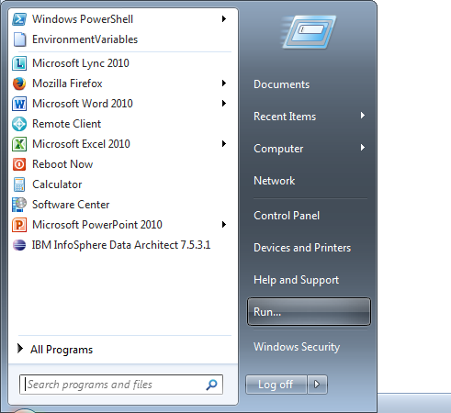

In the resulting “Run” pop-up, enter:

mstsc /admin

and click OK

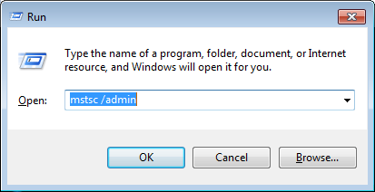

In the Remote Desktop pop-up window, enter the name of the server on which you intend to install the client and press “Connect”

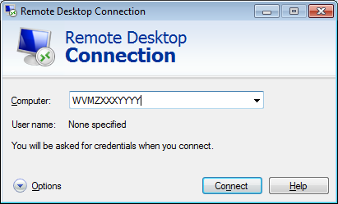

Click the “Options” button and then the “Display” tab. Make sure that the “Display Configuration” slider is moved to the far right for “Full Screen”. Then click “Connect”.

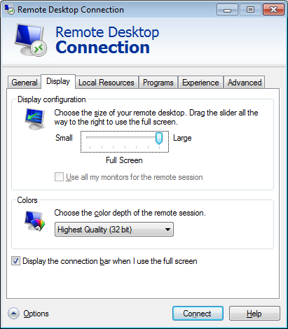

In the “Windows Security” pop-up, choose “Other User” and enter your ZZ-id and password.

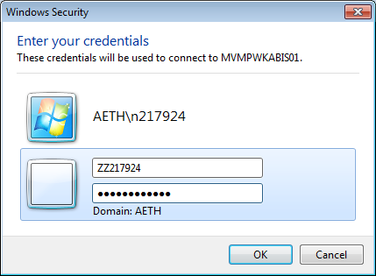

# Start file explorer and command windows to do the install

Move your mouse to the far top-right corner of the window and you should see a magnifying glass (search). Click on that and you should get a search text box. In that text box, type “file explorer”. On the left-hand side of the window, you should see an icon for “File Explorer”. Click that.

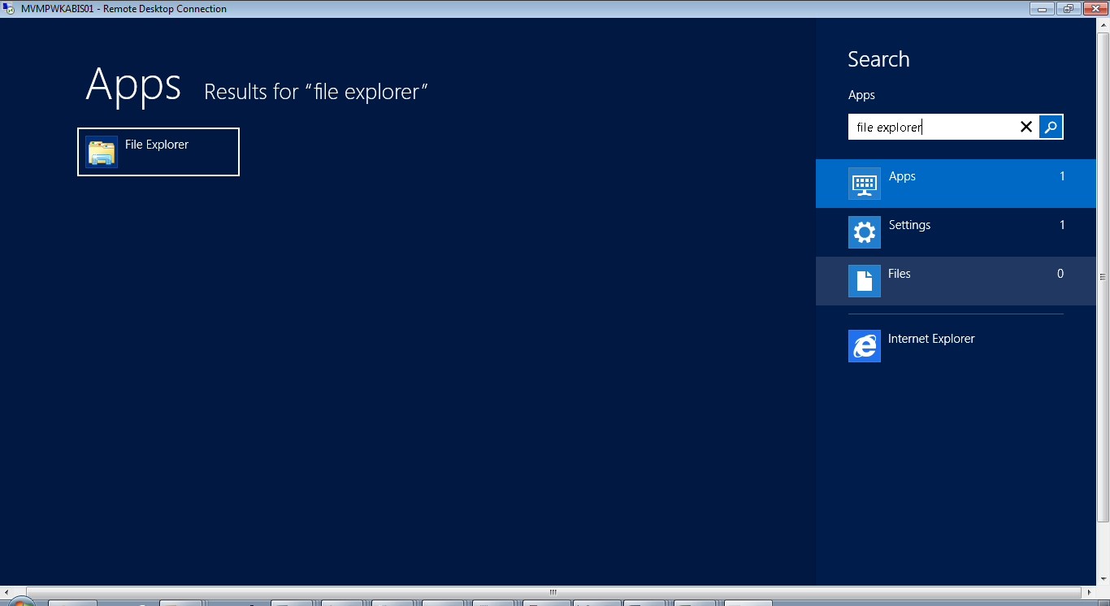

Again, move your mouse to the top-right corner of the window to get the magnifying glass. Click it and type “command” in the search box. You will see a “Command Prompt” icon on the left-hand side of the window. Right-mouse on it and you will see options at the bottom of the screen. Of those options, click on “Run as Administrator” and answer “Yes” to the resulting pop-up security box.

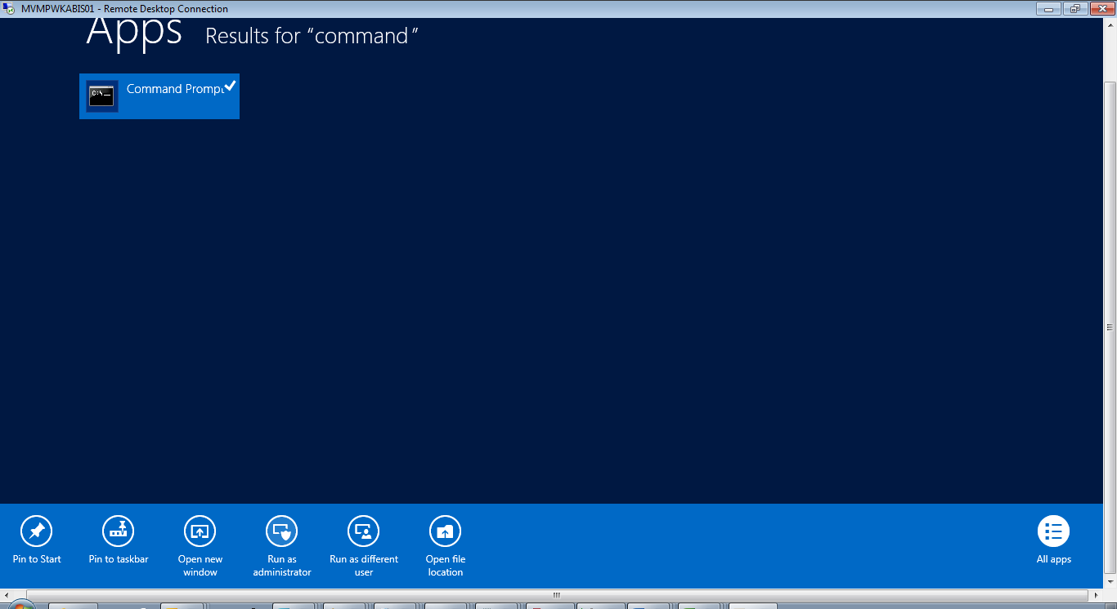

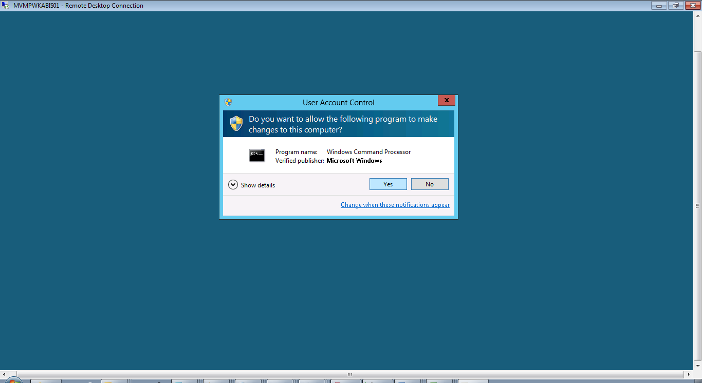

As an alternative to moving the mouse around, if you are in full-screen mode for the remote desktop, you can hit the “Windows” key plus the X key. This will open up a shortcut menu that has both “File Explorer” and “Command Prompt (Admin)” options. You can use this to launch the file explorer and command windows.

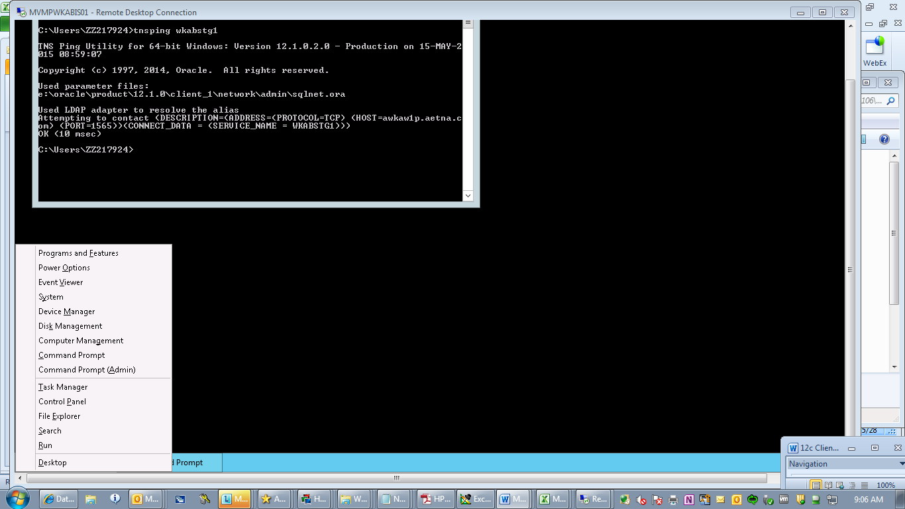

# Copy the software to the server.

Now, in the File Explorer window, click in the address bar and type:  
\\WVMPWKABIS01\e$

or   
\\MVMPWKABIS01\e$

or

\\WVMQWKABUTAP20\e$

Your copies will go faster if you chose a server in the same data center to copy from. After you type this in the address bar, hit “Enter” and it should display the contents of the e-drive on the remote server.

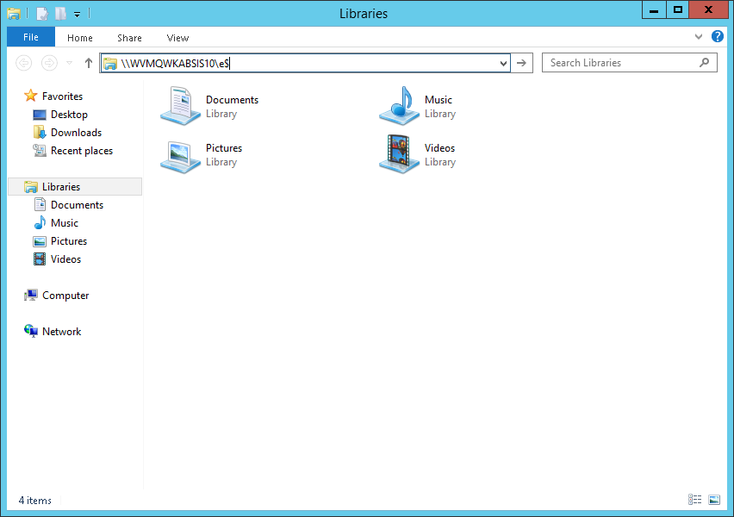

In this window, right mouse on the “Oracle_12102ClientStage” directory and choose “Copy”.

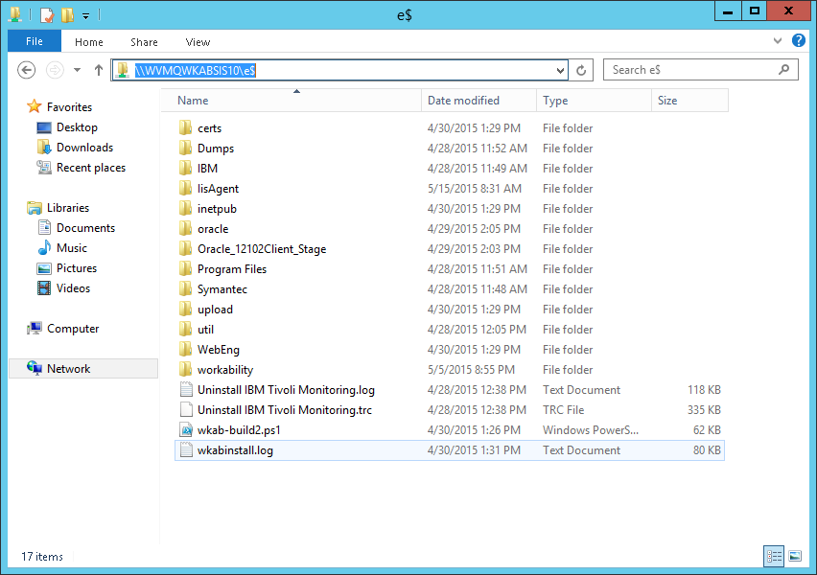

The right-mouse on the “Computer” icon on the left-hand side of the file explorer window and choose “Open in new window”. This will launch another file explorer window.

In the new File Explorer window, click on the “E-Drive” icon and it should display the contents of the local E-drive. Right mouse in an empty portion of the window and choose “Paste” to copy the software from the other server.

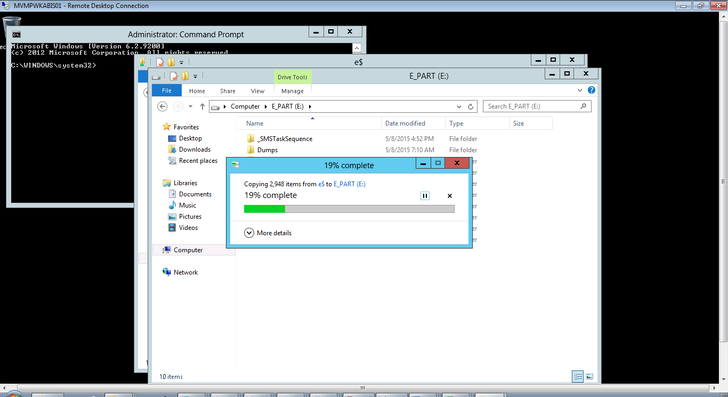

# Run the Install

Once the software has copied over, click on the “Command Prompt” Run As Administrator window. In this window, type :

e:

followed by:

cd Oracle_12102Client_Stage (you can just say cd oracle* if you want)

You should now be positioned in the e:\Oracle_12102ClientStage directory.

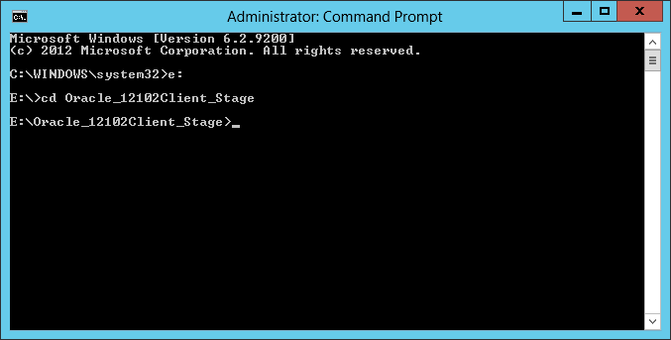

Now, in this window, type:  
run_install.bat

and hit “Enter”. A new window will pop-up.

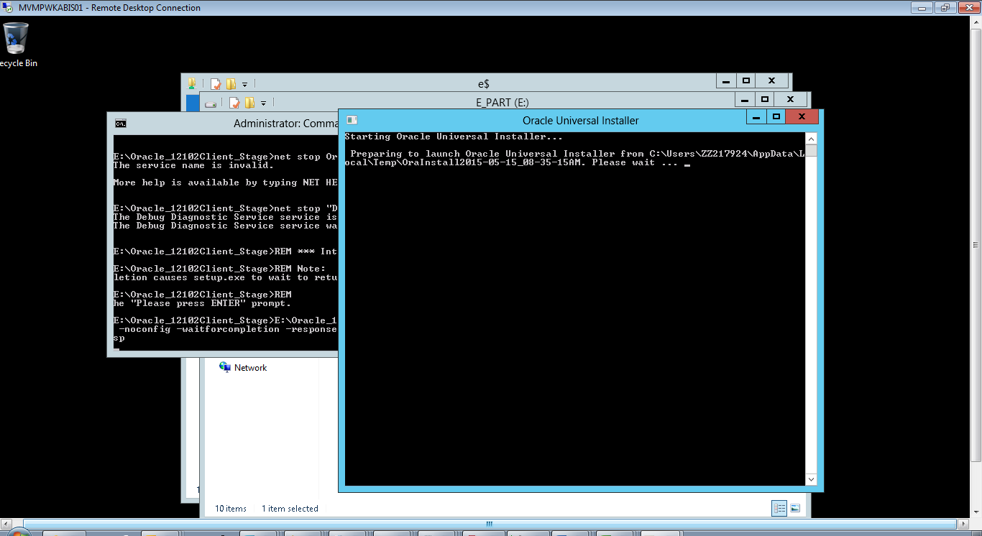

Watch this window and wait until it says "Press enter to exit". Review output above that. It should say something like:

The installation of Oracle Client 12c was successful.

Please check 'C:\Program Files\Oracle\Inventory\logs\silentInstall2015-04-23_09-

21-39AM.log' for more details.

Successfully Setup Software.

As install user, execute the following script to complete the configuration.

1. e:\oracle\product\12.1.0\client_1\cfgtoollogs\configToolAllCommands R

ESPONSE_FILE=<response_file>

Note:

1. This script must be run on the same host from where installer was run

.

2. This script needs a small password properties file for configuration

assistants that require passwords (refer to install guide documentation).

Please press Enter to exit...

If things look good with that, then press “Enter” and the window will disappear and you will be returned to the original command prompt window.

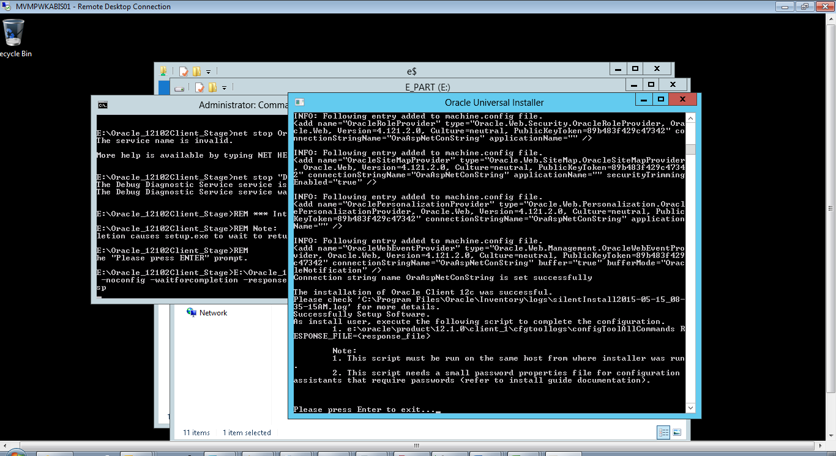

The original command prompt will now be prompting you to press any key to continue. If the previous step was OK, then press a key. This will cause it to install the patchset on top of the base install. If you see prompts to enter “y/n” for portions of the patch install, ignore these, they will be answered automatically.

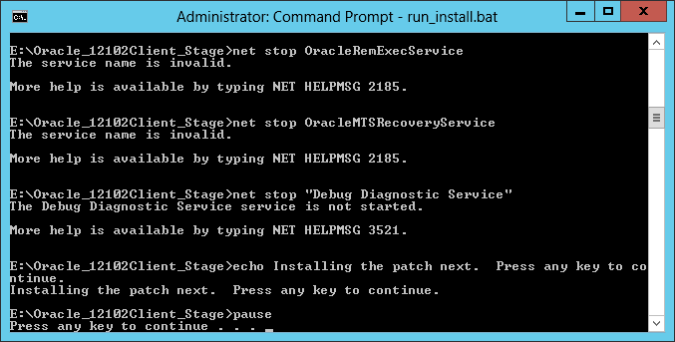

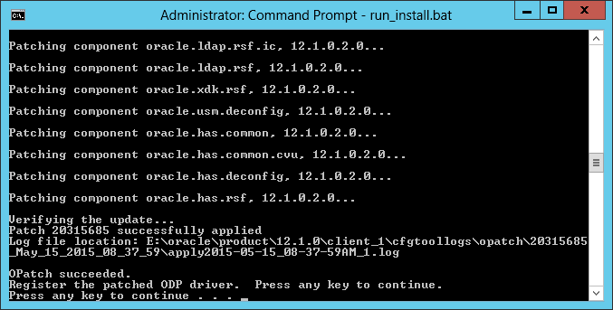

When patching is complete, you will again be prompted to press a key to continue. First, review the patching output. It should end with something like the following.

Should say:

OPatch succeeded.

Register the patched ODP driver. Press any key to continue.

Press any key to continue . . .

If so, then press a key to continue with configuring and updating the ODP drivers.

At the end of the patch application, the output should look something like:

INFO: e:\oracle\product\12.1.0\client_1\odp.net\bin\4\oracle.dataaccess.dll is r

egistered successfully in GAC.

INFO: e:\oracle\product\12.1.0\client_1\odp.net\publisherpolicy\4\policy.4.112.o

racle.dataaccess.dll is registered successfully in GAC.

Copy the oracle network files. Press any key to continue.

Press any key to continue . . .

If so, press a key to continue with copying the network configuration files.

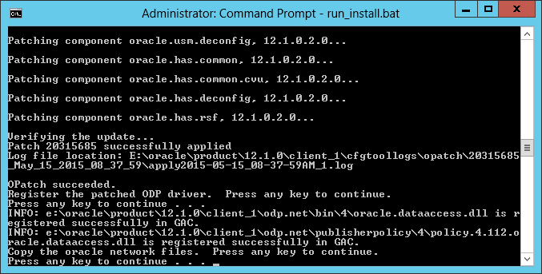

The output for configuring the network files should look something like the following:

E:\Oracle_12102Client_Stage\ldap.ora

E:\Oracle_12102Client_Stage\sqlnet.ora

E:\Oracle_12102Client_Stage\tnsnames.ora

3 File(s) copied

E:\Oracle_12102Client_Stage>

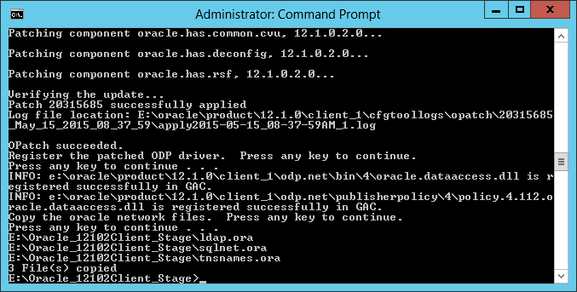

# Restart the server

Move your mouse to the top-right of the screen and click on the gear for settings. Click on the “Power” icon.

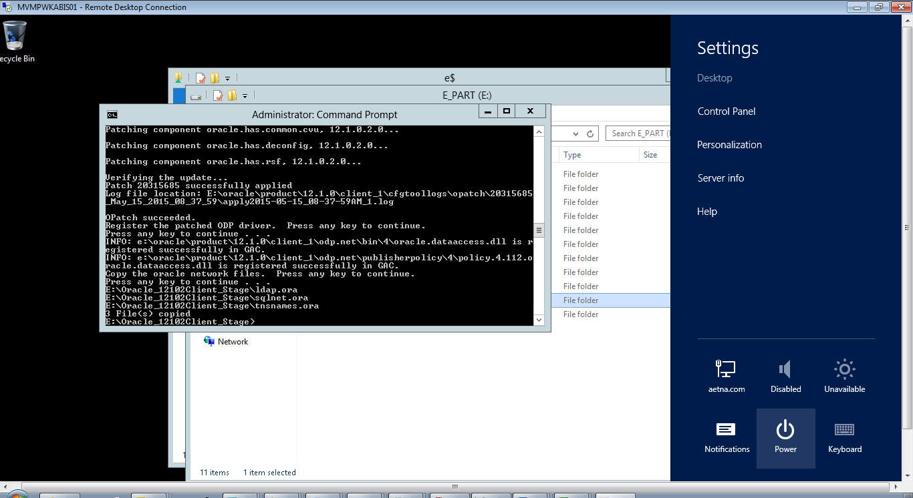

Then choose the “Restart” option.

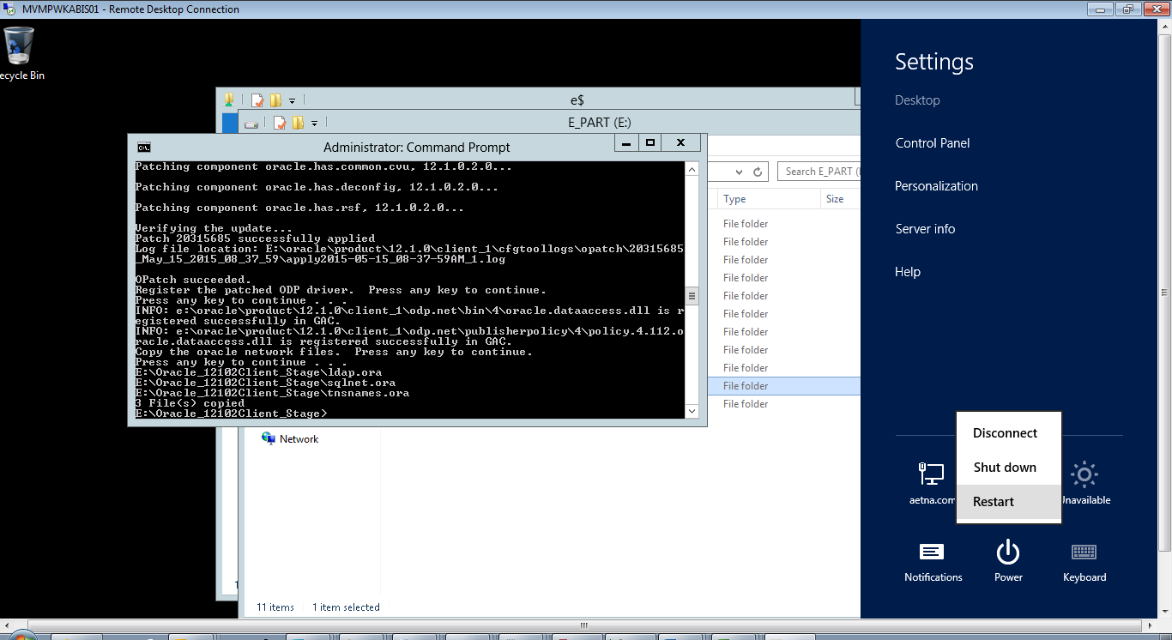

In the pop-up, choose “Application Installation” for the restart reason and click OK. The machine will now restart.

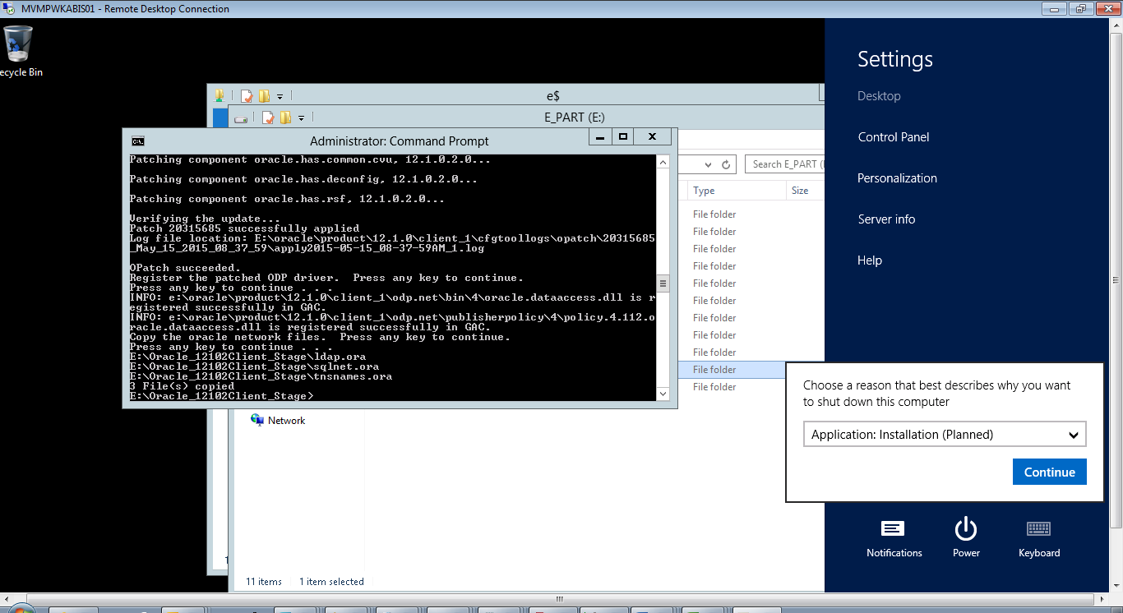

# Verify installation

It will take some time for the machine to reboot, but to test the installation afterwards, repeat the login procedure and open a new “Command Prompt” window. In that command prompt window, type:

tnsping wkabprod

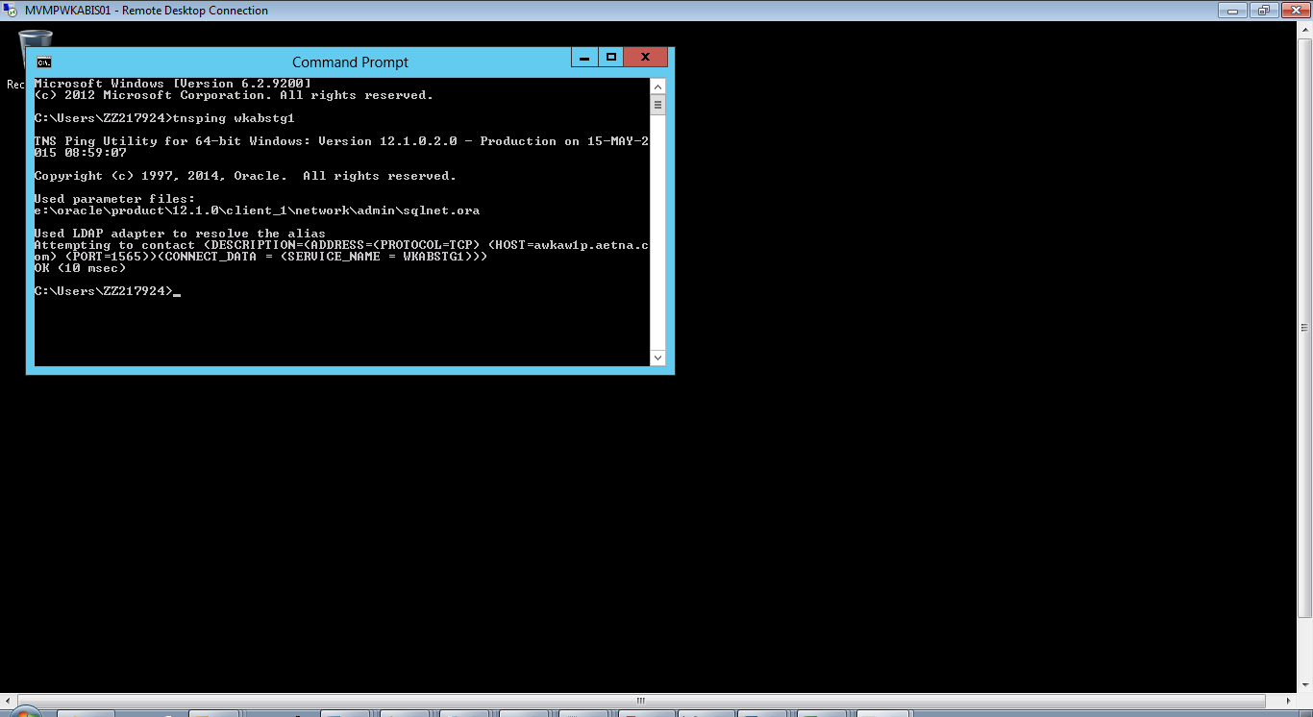

You should be able to tnsping your target database successfully.

# Log off your terminal session

Move your mouse to the top-right corner of the window and click on the “Start” icon.

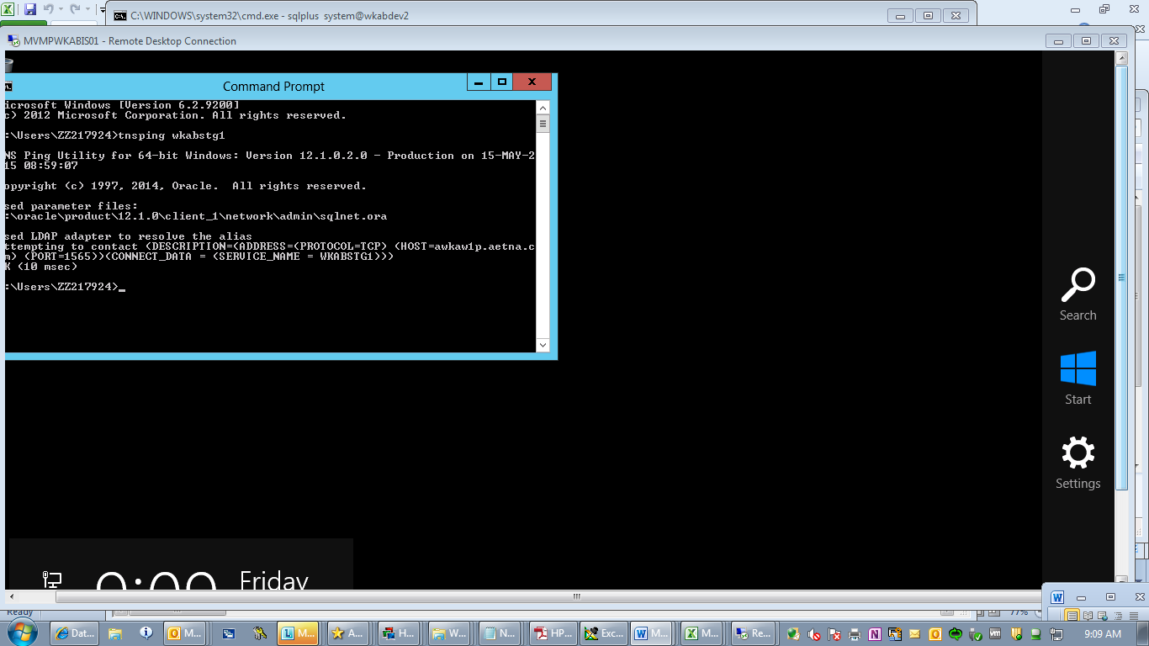

In the top-right corner again, click on your name and choose the “Sign out” option.

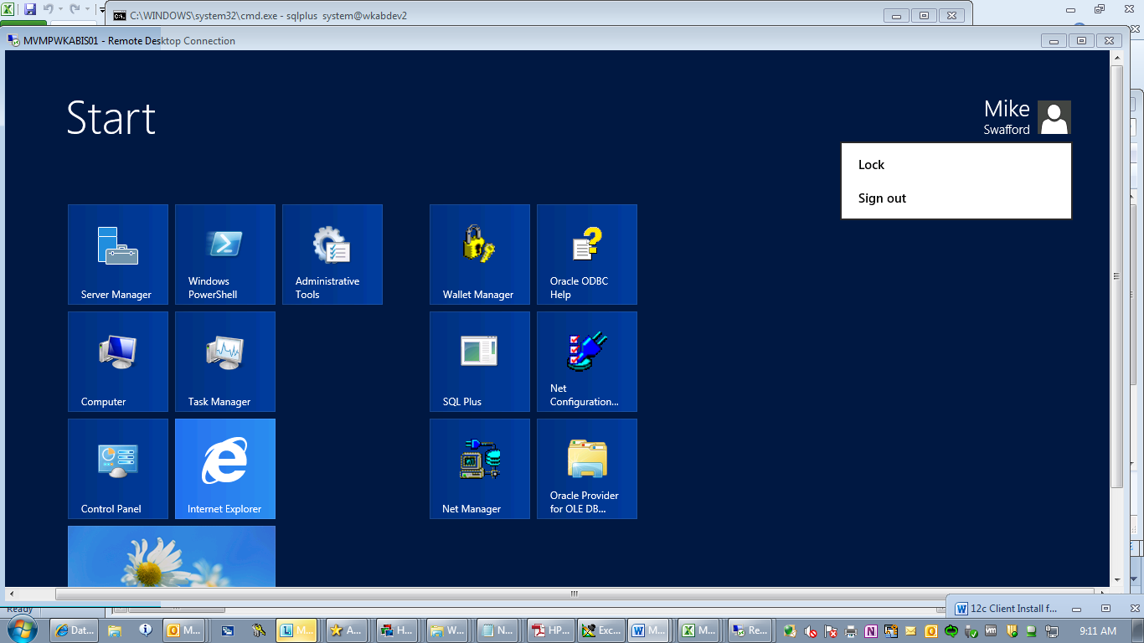

Installation is now complete.